**Assignment 35.1**

**Problem Statement:**

● Create an employee table in Mysql and columns as Emp_id, Emp_name, Dept_name(Hadoop Developer), Emp_sal.

● Import the employee table contents into the HDFS directory using Sqoop.

● Create a employee2 table in Mysql and Export employee details file from HDFS directory to Mysql table employee2 using Sqoop.

● Explain the procedures performed, Share the screenshots of commands and results for the same.

**Solution:**

Apache Sqoop is a tool designed for efficiently transferring bulk data between Apache Hadoop and structured datastores such as relational databases.

* **Creating table ‘emp’ in MYSQL:**

First we have to login to your MySQL shell.

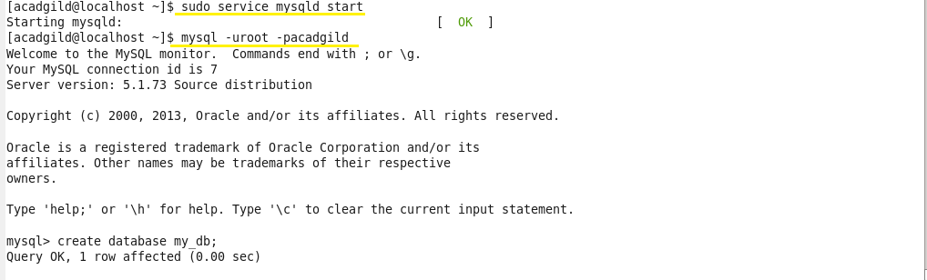

Creating a database by using the **‘create’** command and to work in the created database, we use **‘use’** command.

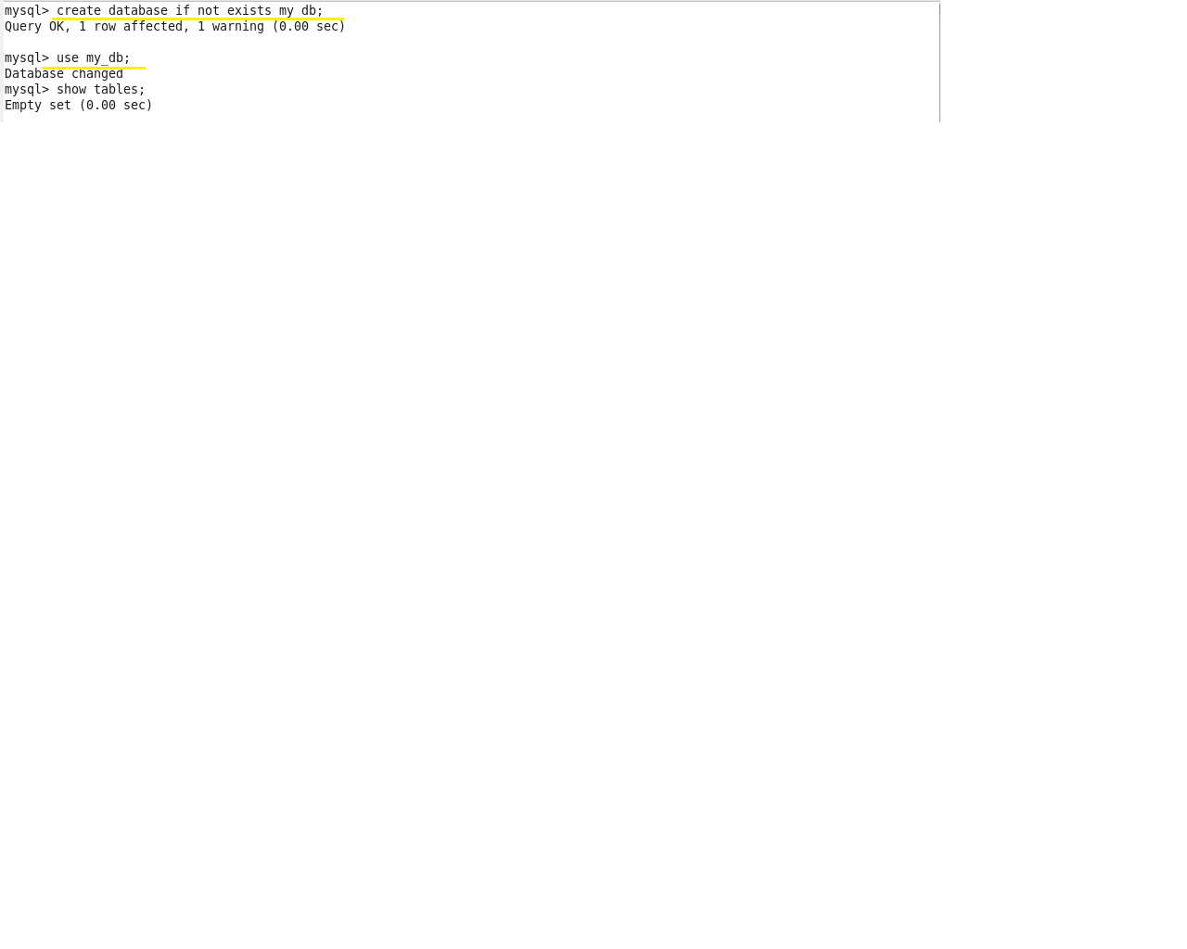

Creating a table **emp** by using the **‘create’** command:

After a table has been created with name **emp** and with the columns id, name, dept, sal. The scheme of this table can be checked using the **‘describe’** command:

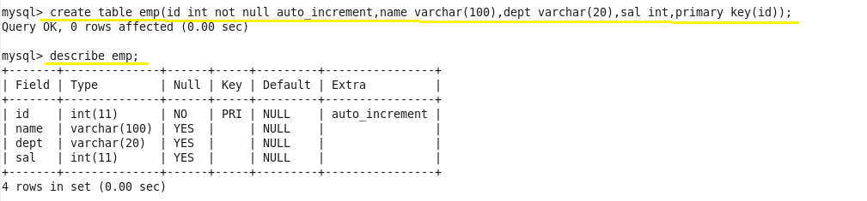

 Inserting some sample data into the created table by using **‘insert’** command:

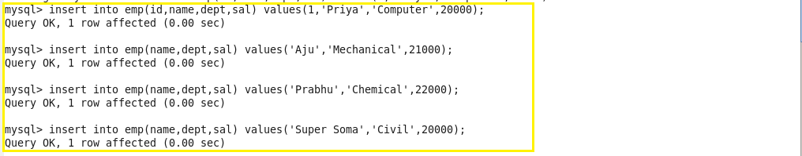

We can check the inserted using this command:

select * from employee;

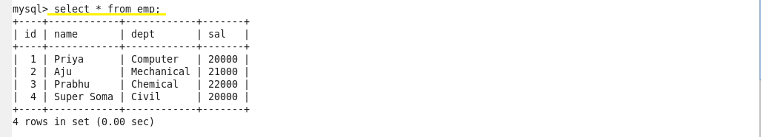

We have successfully created a table in MySQL, and we will now import the same into HDFS by using Sqoop.

* **Importing a Table from RDBMS to HDFS:**

Here we are using a sample MySQL data and importing it into HDFS using Sqoop. Let us see how to create a table in MYSQL.

The following command can be used to import the table into HDFS.

Here we are connecting to MySQL through JDBC connectors and using the database Acadgild. Here it is necessary to specify the MySQL ‘s username and password and the table name.

The command will be as shown below:

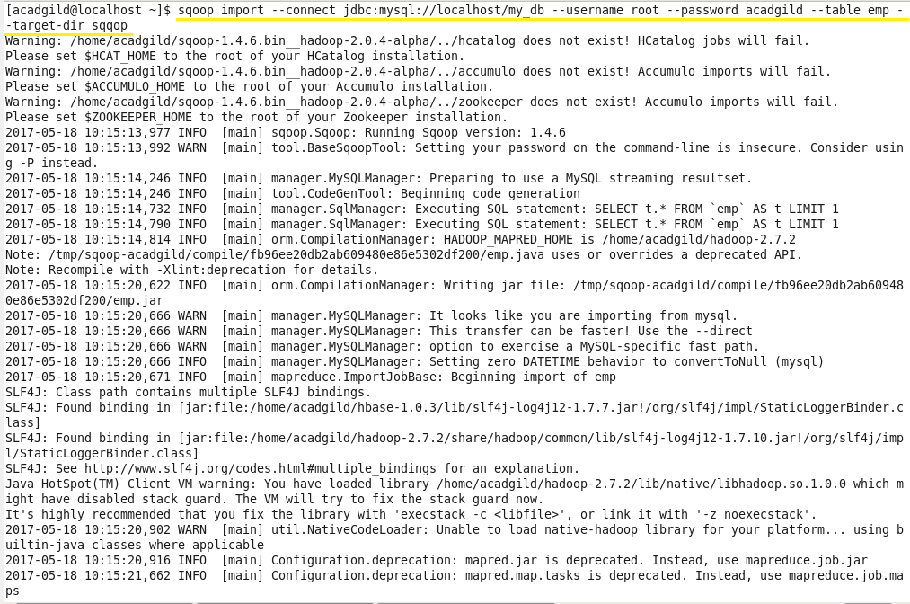

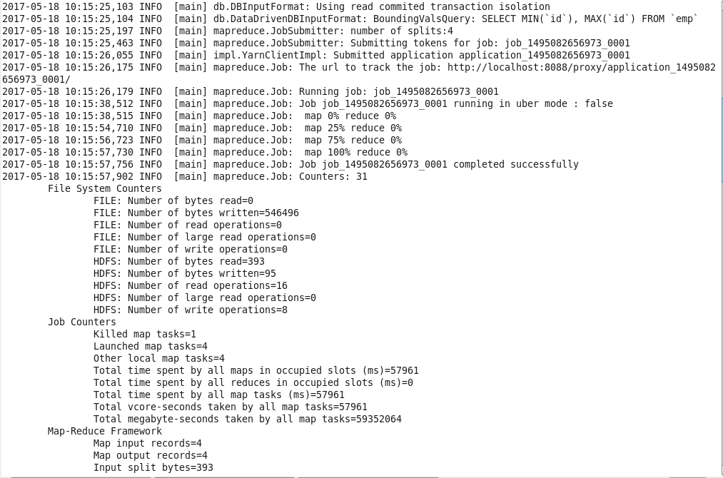

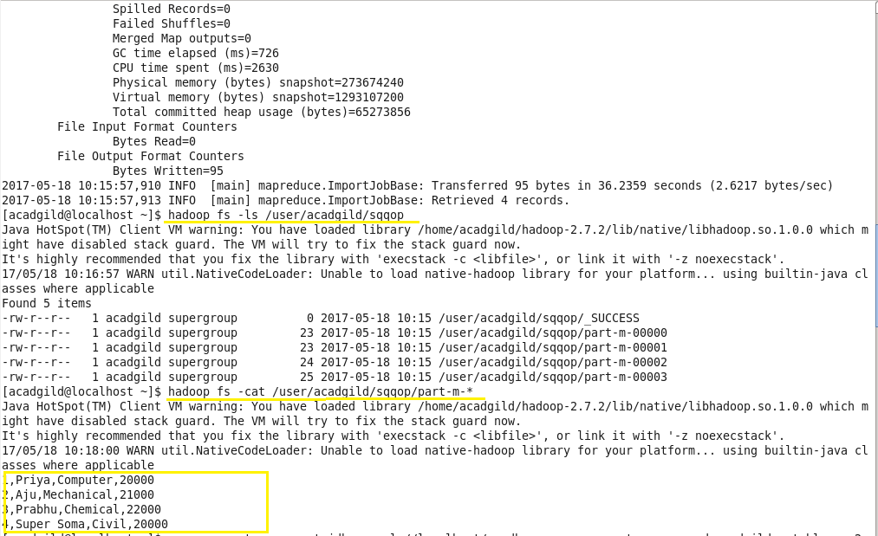

* **Creating table ‘emp2’ in MYSQL:**

To export the data in HDFS to MySQL, first we need to create a table in MYSQL which matches the schema of the data in HDFS.

We created table emp2 in database my_db.

We can check the schema of the created table using the following command:

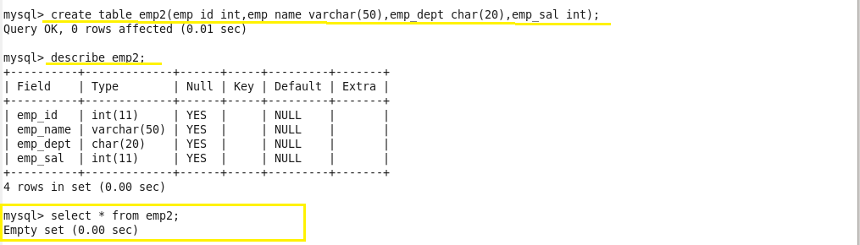

* **Export Data from HDFS to RDBMS:**

We will now export the data in above location of HDFS into RDBMS using Sqoop, through the below command:

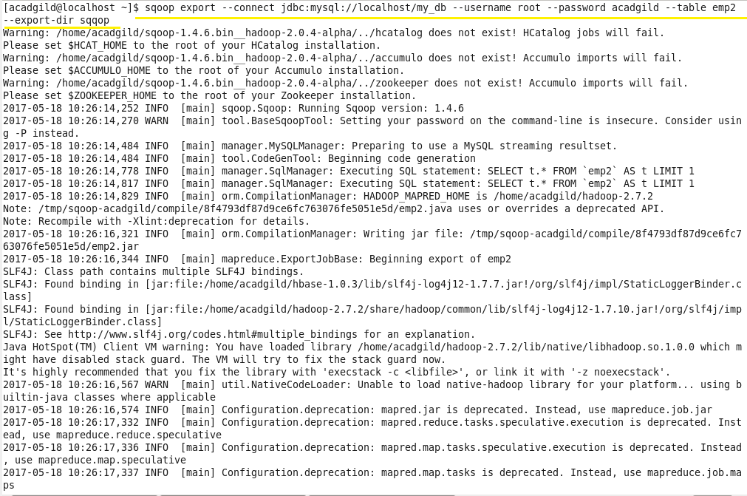

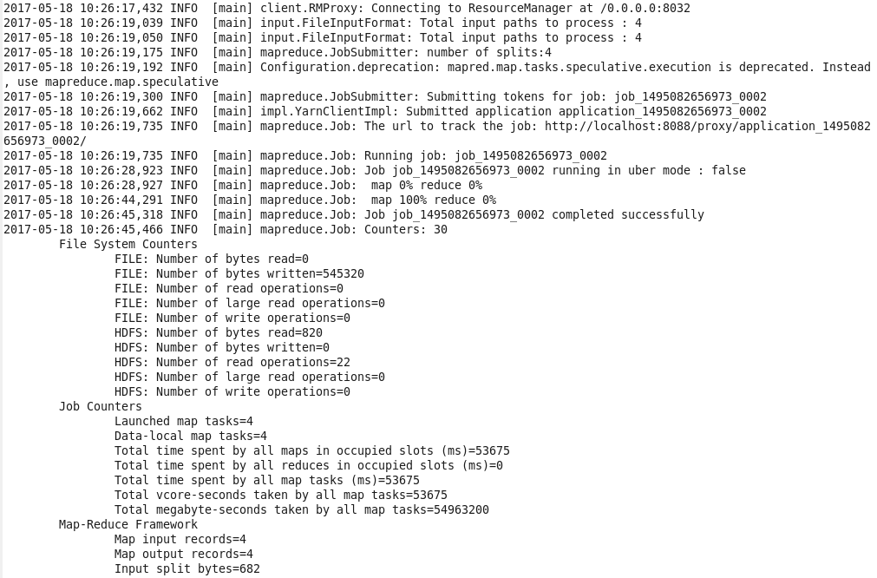

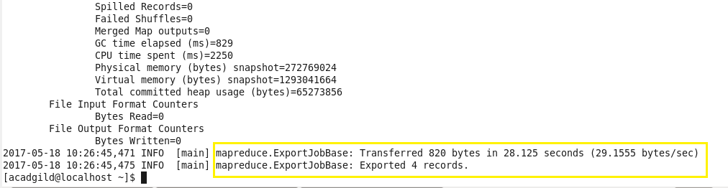

The data has now been successfully transferred from HDFS to RDBMS. We can check the data in MySQL using the below command:

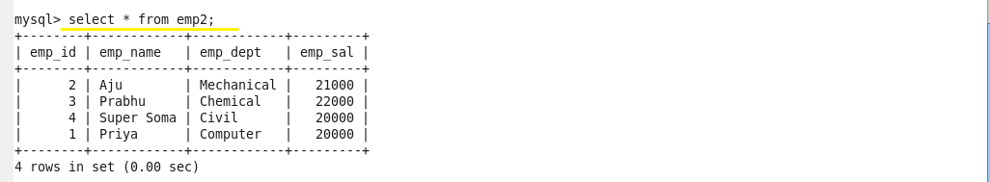

We can see that the contents of dataset is now available inside the table emp2, which is present in MySQL. Thus we have successfully transferred data from HDFS to RDBMS.